**Driver Vehicle Preparation**

***Work-flow to Use Boarding Time Relaxation***

There is currently one Optibus template



Use **Load Template** to set up the preference



Repeat **Load Template** for additional instances of the template



***Preference Overview***

This preference adds driver vehicle preparation time to the beginning of a duty.



You cannot use Driver Vehicle Preparation together with Pre Trip from the

**Pre Post Trip** preference

You can use it together with driver sign on from the **Driver Signing** pref- erence

Driver vehicle preparation time affects both the Vehicles and Drivers Gantts. It uses the

element. if we set driver vehicle preparation time to 10 min, the associated inform-



ation box from the Vehicles Gantt looks like this:

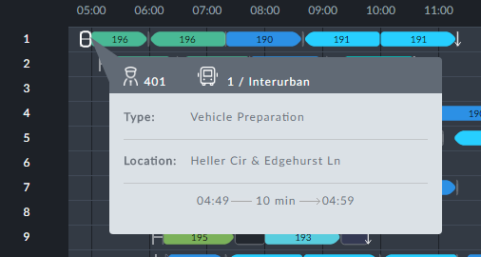

If we look at duty 401 in the Drivers Gantt, we see this:

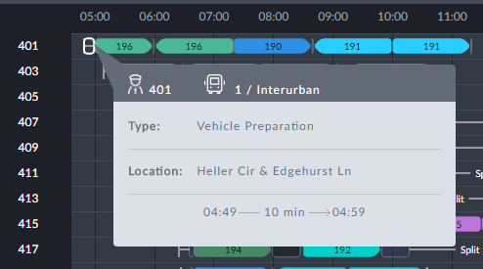

If you also have sign on time, the same element looks like this:

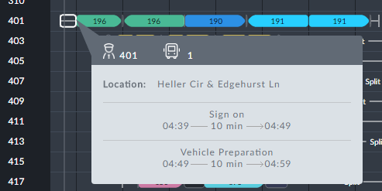

Driver sign on time and driver vehicle preparation are separate and complimentary.

***Templates Available from Optibus***

***Driver Vehicle Preparation***

**Purpose:**

As described in the Overview. **Prerequisites:** None.

**Opening Dialog:**

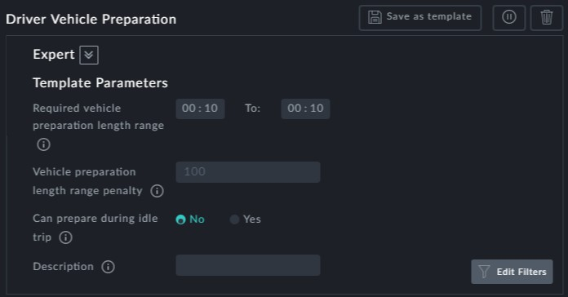

**Points to note:**

**Required vehicle preparation length range**: You can specify a time range or a single time by setting the same value in both of the range fields. Use a range if you intend to set the next penalty field.



**Vehicle preparation length range penalty**: The penalty you set increases pro- portionally from zero at the low end of the range to your set value at the high end of the range.



**Can prepare during idle trip**: For example, set this to Yes if you wish to include driver vehicle preparation in depot pull out time



**Description**: An optional field for use in reports. It is not displayed in the Gantts.

